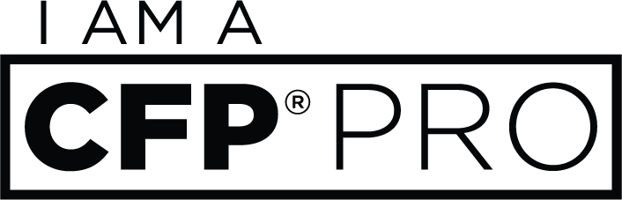

Social Media Toolkit for
CFP Board Registered Programs

As part of the “I am a CFP® Pro” campaign to attract more young people into the financial planning profession, the following are suggested social posts that academic institutions offering CFP Board Registered Programs are encouraged to share on their social channels.
Helpful Links:

“I am a CFP® Pro” campaign website: www.CFPpro.org
Includes testimonial videos from real CFP® pros on why they love their career
Resources for Education Partners: https://bit.ly/2GwOxoD
Information, forms and updates related to CFP Board Registered Programs

General Tweets:
- Considering what to do as a future career? Visit www.cfppro.org to learn about financial planning & why you’d make a great fit! #CFPPro
- Looking for a rewarding, flexible career after graduation? Check out www.cfppro.org to find out if becoming a CERTIFIED FINANCIAL PLANNER™ professional is right for you #CFPPro
- Careers in financial planning are in high demand! We have a @CFPBoard Registered Program to help students prepare for this growing field. Learn more at [INSERT LINK TO PROGRAM WEBPAGE] #CFPPro
- Financial planning is an in-demand career involving a variety of skills. Discover what it takes to become a CFP® pro at www.cfppro.org and consider majoring in financial planning #CFPPro
- Undeclared and unsure what you want to do after graduation? Check out our @CFPBoard registered financial planning program #CFPPro [INSERT LINK TO PROGRAM WEBPAGE]
- Have you considered majoring in financial planning? Explore potential job opportunities and hear from CFP® professionals on what a career in financial planning has to offer #CFPPro www.cfppro.org
- Careers in financial planning are about more than just money – they offer flexibility & the opportunity to provide guidance to others. Learn more at www.cfppro.org #CFPPro
- Ever consider majoring in financial planning? Check out day-in-the-life videos of CERTIFIED FINANCIAL PLANNER™ professionals at www.cfppro.org #CFPPro
- If you are one of the many students who feels unsure of what your future holds, gain some clarity by looking into our @CFPBoard Registered Program for a future in financial planning [INSERT LINK TO PROGRAM WEBPAGE] #CFPPro
- Do you or anyone you know enjoy helping others and have an interest in finance? Explore the @CFPBoard Registered Program we offer and spread the word! #CFPPro www.cfppro.org
- Hoping to make a positive impact in others’ lives? CERTIFIED FINANCIAL PLANNER™ certification provides the training and expertise to help make a difference. Learn more about majoring in financial planning here [INSERT LINK TO PROGRAM WEBPAGE] #CFPPro www.cfppro.org
- Interested in learning about the financial planning profession? Visit @CFPBoard’s “I am a CFP® Pro” campaign to get info straight from the pros #CFPPro www.cfppro.org

Facebook/ LinkedIn Posts:

- For anyone contemplating what to major in, we are proud to offer a program in financial planning. Students who complete the program will have satisfied the education coursework requirement to sit for the CERTIFIED FINANCIAL PLANNER™ Examination. Learn from CFP® professionals about a career field that is rapidly growing and constantly in-demand at www.cfppro.org #CFPPro
- Interested in an exciting and rewarding career following graduation? Consider becoming a financial planner. CERTIFIED FINANCIAL PLANNER™ professionals help numerous individuals and families take control of their money and reach more than just financial goals. Financial planning is an in-demand career that fosters personal development and fulfillment. Check out www.cfppro.org to learn more about the career and ask us about our CFP Board Registered Program and to get started! #CFPPro

